PYTHON-11 |
ERROR AND EXCEPTION HANDLING

1. Python Error Handling:

1. Introduction to Error Handling:
Error handling is the process of dealing with errors that may occur during program execution.

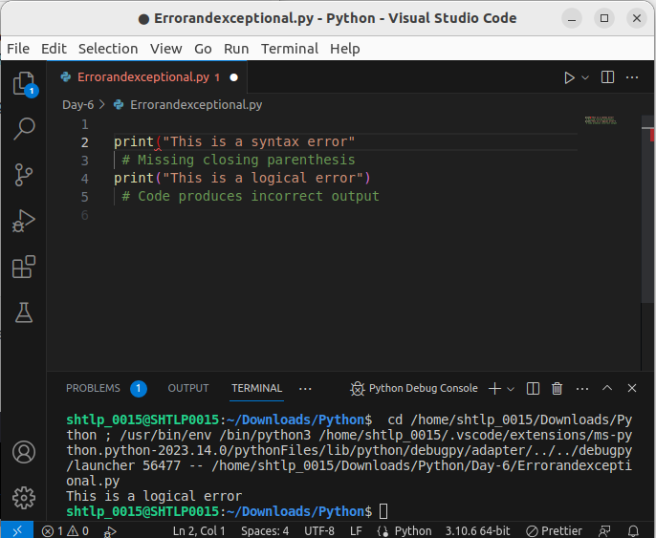
.

2. Types of Errors:
- Syntax Errors: Violations of the language's syntax rules. Code doesn't run.
- Logical Errors: Mistakes in program logic. Code runs but produces unexpected results.
- Runtime Errors (Exceptions): Errors that occur during execution, like division by zero or accessing nonexistent elements.

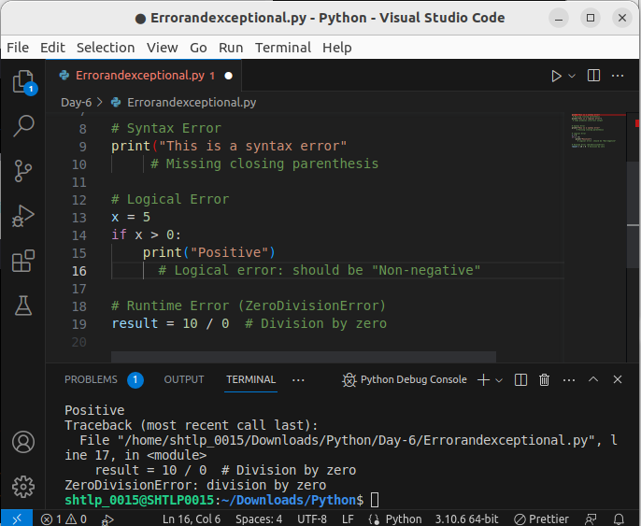

3. Syntax Errors and Debugging:
- Syntax errors are caught by the interpreter when the code is being parsed and prevent execution.

- Syntax errors are caught by the interpreter during parsing.

4. Logical Errors and Debugging Strategies:

- Logical errors lead to undesired behavior. Debugging strategies involve examining code, variables, and logic.

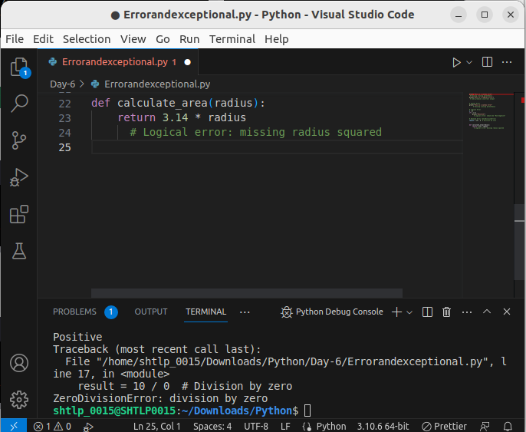
.

5. Introduction to Exceptions:

- Exceptions are runtime errors that can be handled to prevent program crashes.

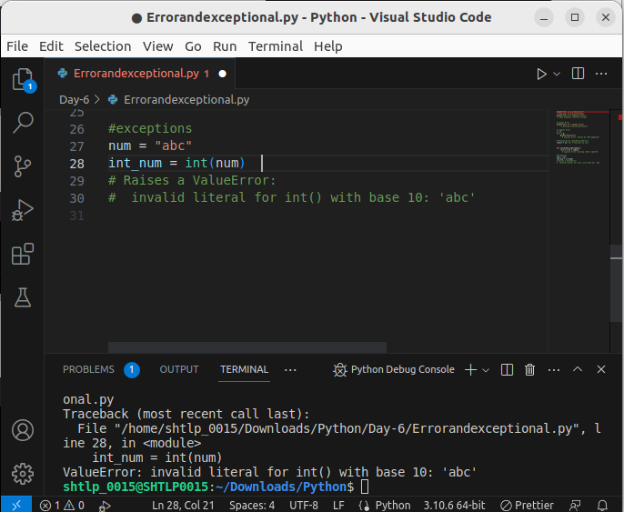
.

‘

6. The `try` and `except` Statements:
Use `try` and `except` to catch exceptions and execute alternative code when an exception occurs.

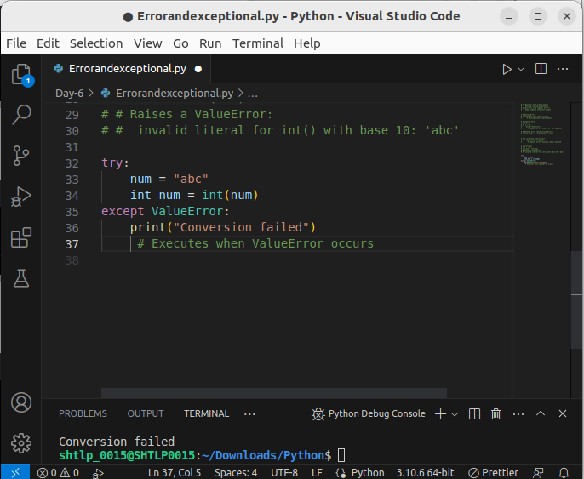
.

7. Catching Specific Exceptions:
Catch specific exceptions using multiple `except` blocks.

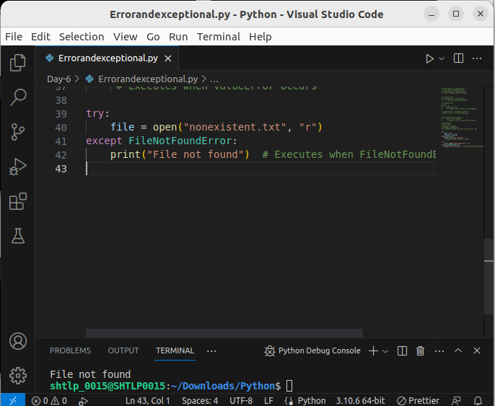

8.The finally Block:
Use the `finally` block to specify code that must run regardless of whether an exception occurs.

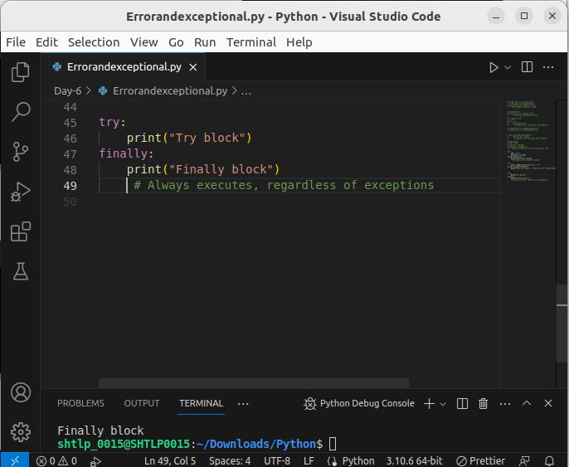

`9. else` with `try`:

Use the `else` block with `try` to execute code only if no exceptions are raised.

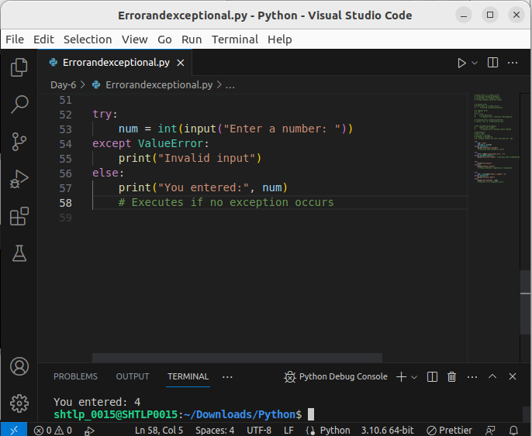

2. Exception Handling:

1.Introduction to Exception Handling:
Exception handling is the process of handling runtime errors gracefully to prevent program crashes.

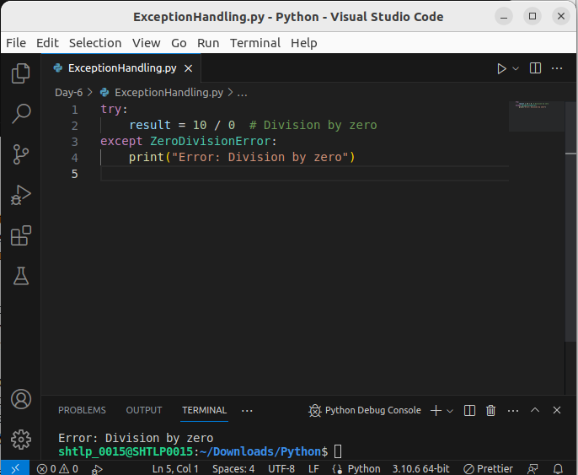

2. Common Built-in Exceptions:
- ZeroDivisionError: Raised when dividing by zero.
- ValueError: Raised when a function receives an argument of the correct type but with an inappropriate value.
- TypeError: Raised when an operation or function is applied to an object of inappropriate type.
- FileNotFoundError: Raised when trying to access a non-existing file.
- KeyError: Raised when trying to access a non-existing dictionary key.

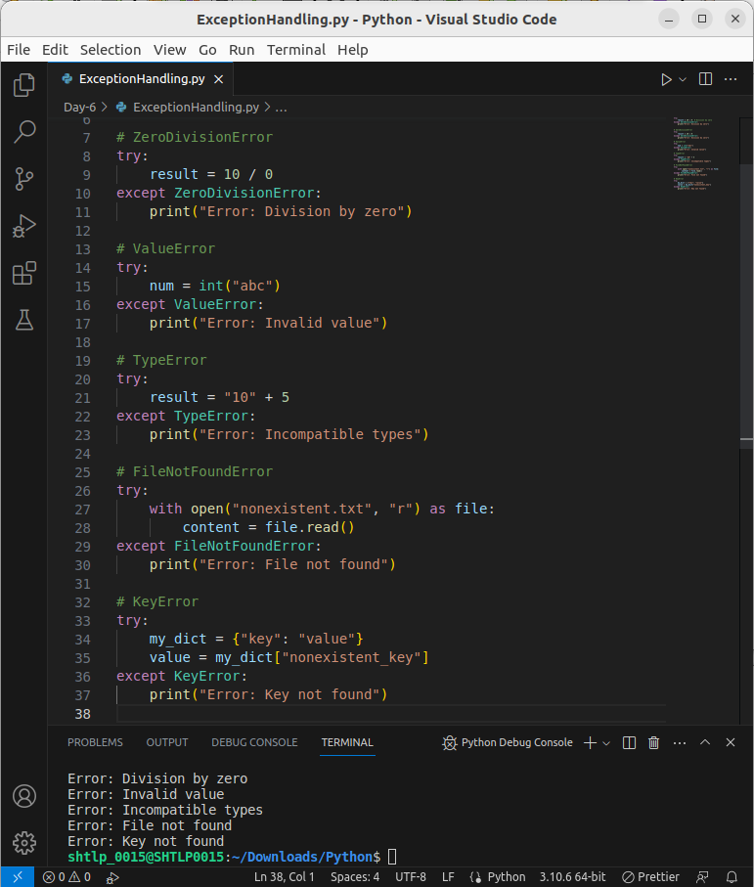
3. Using `except`:
The `except` statement is used to catch and handle exceptions.

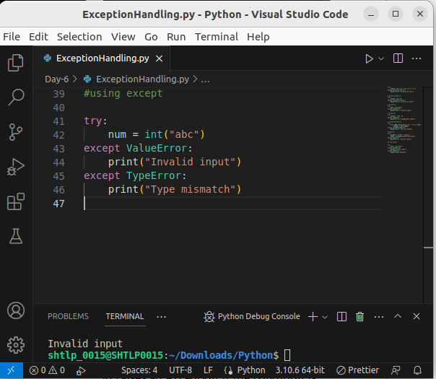

4.Using `assert`:
The `assert` statement checks a condition and raises an exception if the condition is `False`.

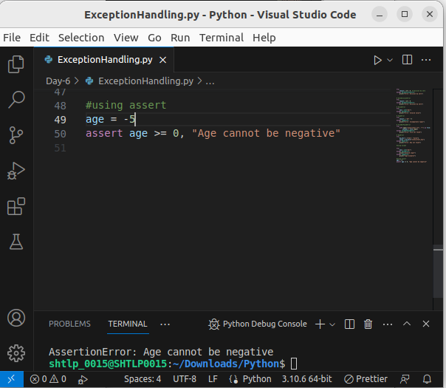

5.Advantage of Exception Handling:
Exception handling improves program stability and provides a graceful way to handle errors.

1. No Crashes:Exception handling prevents your program from crashing when something unexpected happens. It keeps your program running even if there's an error.

2. Clear Errors:When errors occur, Python gives you clear messages that tell you exactly what went wrong. This helps you quickly find and fix mistakes.

3. Easier to Read: Exception handling separates error-fixing code from your main code. It makes your program easier to read and understand because you don't mix error checks with regular actions.

4. Polite to Users:If your program has a user interface, exception handling lets you show nice error messages to users instead of showing them confusing technical errors.

5. Faster Fixes: When something goes wrong, Python shows you where the problem happened. This helps you find and fix the issue faster, saving you time during development.

6. Limitation and Disadvantages:
- Overuse can make code complex.
- Hidden errors might be masked.
- Debugging can become challenging when exceptions are caught too broadly.

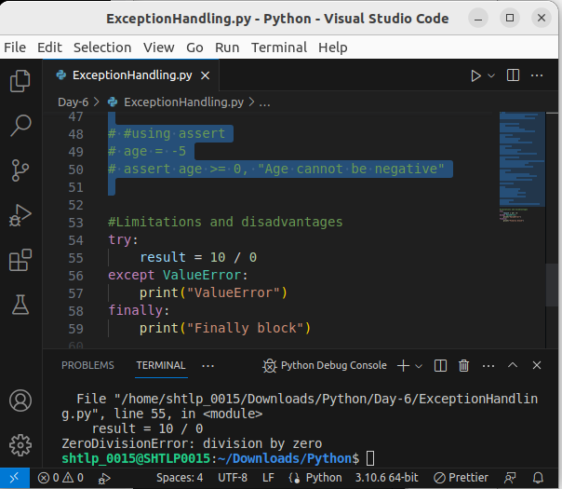
.

Example for Catching Specific Exception (FileNotFoundError):
